**P250/1**

**GEOGRAPHY**

**(Physical Geography)**

Paper 1

Jul/Aug 2019

3 Hours



**MUKONO EXAMINATION COUNCIL**

**Uganda Advanced Certificate of Education**

**GEOGRAPHY**

**(Physical Geography)**

Paper 1

3 Hours

**INSTRUCTIONS TO CANDIDATES**

*This paper consists of three sections* ***A****,* ***B*** *and* ***C****.*

*Answer only* ***four*** *questions in all.*

*Section* ***A*** *is compulsory.*

*Answer* ***one*** *question from section* ***B*** *and* ***one*** *from section* ***C****.*

*Any additional question(s) attempted will not be marked.*

*Credit will be given for the use of relevant diagrams and specific examples studied in the field.*

**SECTION A**

*Question 1 and 2 are Compulsory*

1. Compulsory Map work question.

Study the 1:50,000 EAST AFRICA (UGANDA) KATUNGURU Map extract part of sheet 76/1, series Y32, Edition 4 – USD and answer the questions that follow.

1. (i) Giving reasons, state the hemisphere in which Katunguru is located ***(02 marks)***

(ii) Calculate the trend of the Loose surface road from Ishasha and Rulshuru (700821) to Kahyoro (763767) ***(02 marks)***

1. Reduce the area East of Easting 76 and South of Northing 88 by 2 times and draw a sketch map on it, make and name;
2. Two physiographic regions
3. Two drainage features
4. One vegetation type
5. Two land use activities

***(11 marks)***

1. (i) What evidence is there to suggest that the land use activities in the area covered by the

map extract are planned?  ***(04 marks)***

(ii) Explain the relationship between relief and communication. ***(routes 06 marks)***

1. Compulsory Photograph Interpretation Question

Study the photograph provided below and answer the questions that follow.

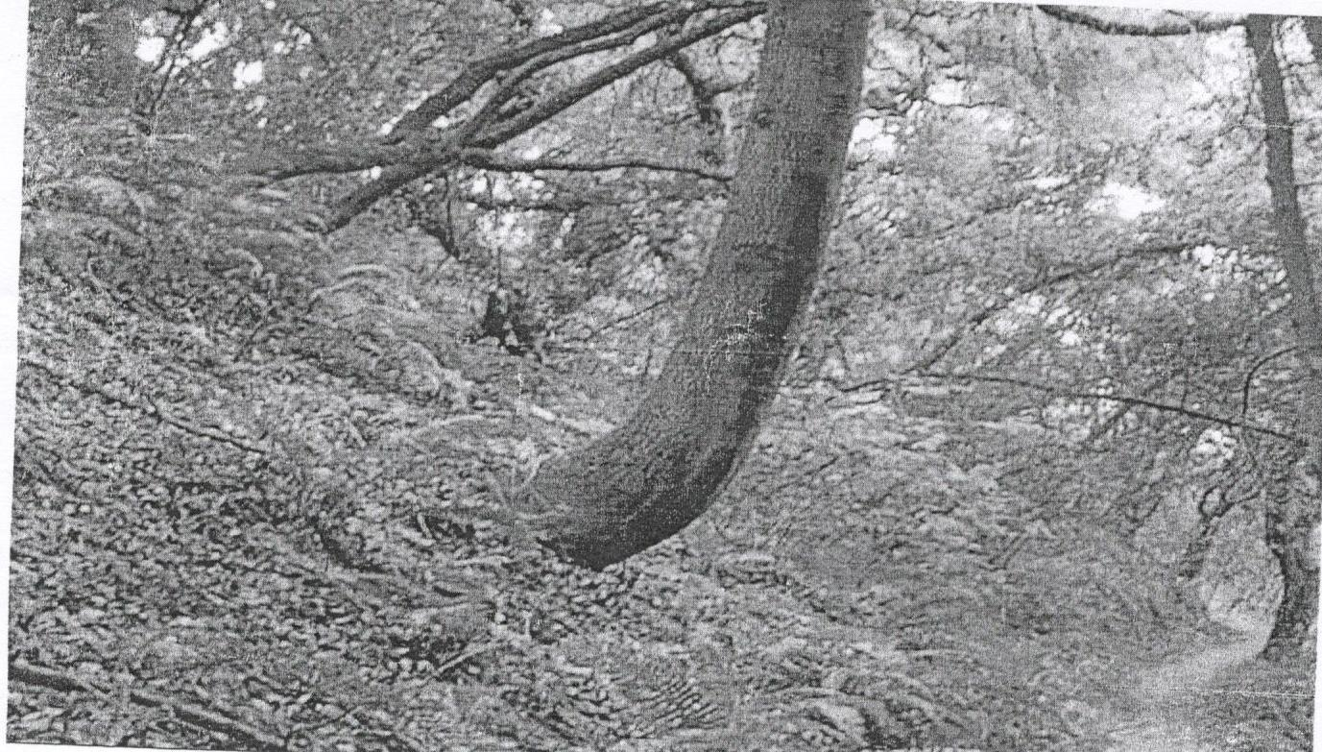

1. Draw a land scape sketch of the area shown in the photograph and on it, mark and name
2. two relief Features
3. two vegetation types
4. one land use type

***(08 marks)***

1. Account for the geomorphic occurrence shown in the photograph above. ***(08 marks)***
2. Examine the control measures that can be adopted to overcome the geomorphic occurrence shown in Photograph above. ***(06 marks)***
3. Giving reasons for your answer, suggest one area in East Africa where the photograph could have been taken. ***(03 marks)***

**SECTION B**

*Answer* ***one*** *question from this section*

1. To what extent are high lands in East Africa a result of diastrophic movements? ***(25marks)***
2. (a) Distinguish between a Gorge and a Plunge Pool.  ***(10 marks)***

(b) Account for the development of a Gorge ***(15 marks)***

1. (a) Describe the characteristics of Coral land forms. ***(09 marks)***

(b) Examine the relevance of Murry’s theory in the understanding of the origin and formation

of Coral landforms. ***(16 marks)***

**SECTION C**

*Answer* ***one*** *question from this section.*

1. (a) Distinguish between Relative and Absolute humidity. ***(08 marks)***

(b) Account for the humidity variations in East Africa. ***(17 marks)***

1. To what extent does latitudinal location influence the distribution of Miombo Vegetation in East Africa? ***(25 marks)***
2. (a) Distinguish between Pedocals and Pedalfers. ***(08 marks)***

(b) Examine the factors that influence the formation of Azonal soils in East Africa.

***(17 marks)***

***End -***